ICT 1 PROJECT DOCUMENTATION

**TEAM MEMBERS**

**NIRAJ**

**PRANATHI**

**PRITPAL**

**RAVIGILL**

1. ICT 1 PROJECT TEAM DESCRIPTION:

Our main goal in this project is to create a website for a business regarding selling “mine 3D dolls” and “3D printouts” online.

TEAM MEMBER: Niraj

RESPONSIBILITY:

1.Select theme

2. Building webpages

3. Insert Plugins

4. Make Login and Logout page

TEAM MEMBER: Pirtpal

RESPONSIBILITY:

1.Collect Information from Client

2. Help in documentation

3. Building webpages & Plugins

4.Create Database

TEAM MEMBER:Pranathi

RESPONSIBILITY:

1.Arrange meetings with Client

2. Documentation

3.Built Agreement

4. Help In user Registration

TEAM MEMBER:Ravi gill

RESPONSIBILITY:

1.Collecting Data

2. Manage Collected information

3.User Training

4. Maintain Database

2.PROJECT DESCRIPTION FOR NON-ICT TECHNICAL STAKEHOLDRES AND AUDIENCE:

1.Justification for the project:

Our project is related to selling mini me 3D dolls and 3d printouts online.As our client wants to start online bussiness for selling 3D he wants us to create a website for his bussiness.Our clients bussiness is all about creating a 3D doll and 3D printouts of either a person,pet or anything.So our main aim is to create the best website with a good ICT solution.Our client focused on online bussiness mainly because most of the people are aware of internet and online shopping is on popular demand as it saves time in this busy life style.We are planning to create website in such a way that it attracts and reaches more number of customers.



2.Project Goals:

As this bussiness plan is a new concept and most of the people are not aware about 3D dolls we planned our website in such a way that just by one click customers gets idea actually what a 3D mini me means.So to make it easy to understand for customers who visit our website for first time we are adding an image of a girl holding her own 3D doll.We are adding some information about the bussiness, different sizes of dolls and their price so that it will be easy for customers to select size of doll depending on how much they can afford,we are adding contact details of the company so that customers can contact them directly if they require.Apart from this we are adding a feed option so that depending on customers feed back improvments can be made according to demand.As our client is planning to provide special discount offers during festive seasons we are adding registration option so that who ever register on our website will receive email regarding special offers.We are designing our website in such away that it can be accesed easily on mobile as most of the people are using smart phones.Our website can be accesed at anytime any day.

(c)Major Milestones:

First milestone according to our priority was to meet the client and deeply understand what is his requirement and what effort should we keep to give the best solution.So every week we are conducting meetings with our client and making notes regarding his requirements up to date.

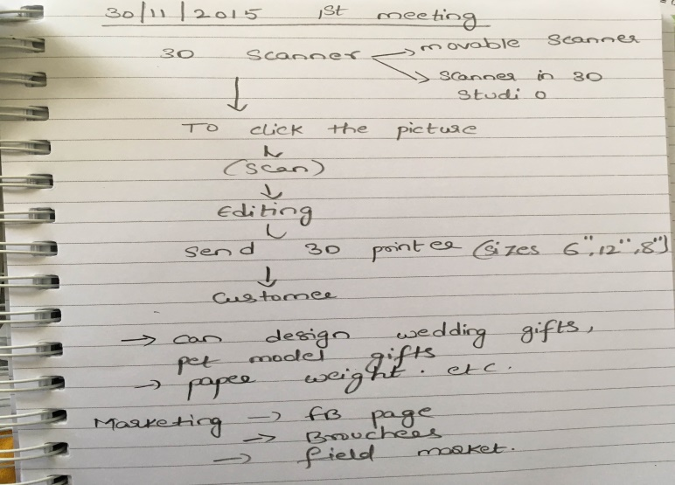

Our next step was to do planning regarding the basic features which we need to include in our website.so we differentiated all the features depending on our clients priority.For example sizes and prices of dolls was one of the major option without knowing the price of a doll a client cannot place an order.

ALPHA RELEASE:We are adding basic features like WHY US,CONTACT US,SHOP, FEEDBACK

BETA RELEASE:We will add registration page and payment methods and anyother options depending on clients requirements.

FINAL RELEASE:

3.PROJECT SCOPE OF FULL FINAL RELEASE:

As this is a real time proposed bussiness which is going to be started from next year(2016).This website helps the customers to order their own 3d doll or print or else they can order for friends as a surprise gift.customers can contact the near by bussiness executive so that the executive visits the customers home for photo shoot or else they can know the details of near by mini me 3D office as well.By the final release we will complete testing and debugging for fixing any existing error.

PROJECT SCOPE OF ALPHA RELEASE:

At the stage of alpha release website includes the basic structure according to client requirement if client is not happy changes will be made further.Some of the features added in alpha release may be removed if the clients requirement changes and new features may be added according to the situation.

Total number of weeks left:5 weeks

Total team members:4 members

Effort per week:1 and half day

Available days:5*4*1.5=30 days

All the user stories for alpha release will be developed in 30 days(approximatly)

USER STORIES

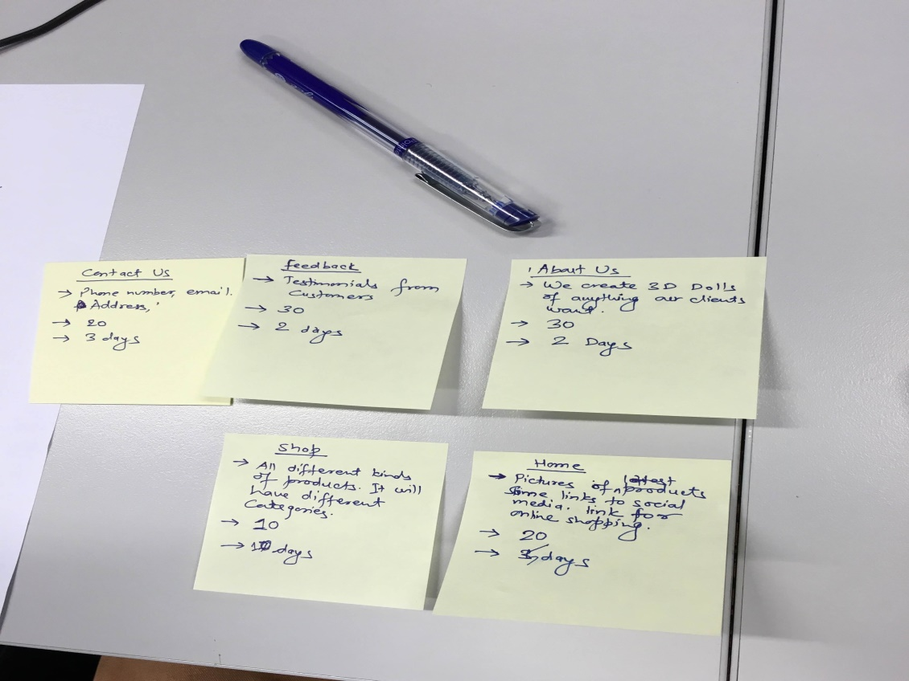

USER STORY 1

TITLE::Contact us

Description:This contains clients contact details ,e mail address

Priority:20

Effort:3 days

USER STORY 2

TITLE:Feed back

DescriptionThis contains testimonals from customers which helps to improve service

Priority:30

Effort:2 days

USER STORY 3

TITLE:About us

Description:This contains brief description about what the bussiness is about and who is the owner etc.

Priority:30

Effort:2 days

USER STORY 4

TITLE:Shop

Description:All different kinds of products and it contains catogeries like sizes prices etc.

Priority:10

Effort:10 days

USER STORY 5

TITLE:Home

Description:This contains pictures of some 3D dolls,links to social media and online shopping

Priority:20

Effort:5 days

4.AGREEMENT:

WILL ADD SCREENSHOTS OF AGREEMENT HERE AFTER RECEIVING FROM CLIENT

5.PROJECT DEVELOPMENT AND RELEASE ICT INFRASTUCTURE:

(a)Configuration Management: GitHub: version control system which responsible for the save the project revisions and also helpful to deal with the other file systems such as word files etc.

(b)Project tools: Dreamweaver and Notepad++ and Wordpress: a tool for web management and source code.

(c)Development Environment: XAMP

(d)Prototypes:

Prototype 1:

Home page:

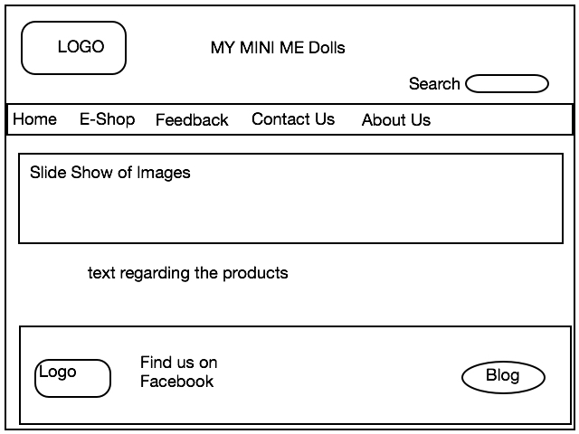

E-Shop:

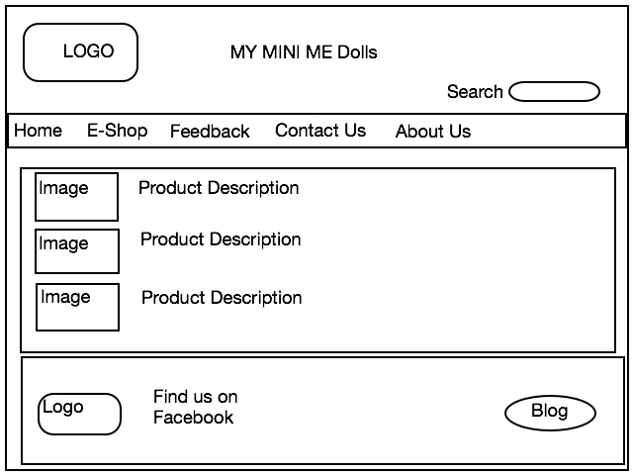

Feedback:

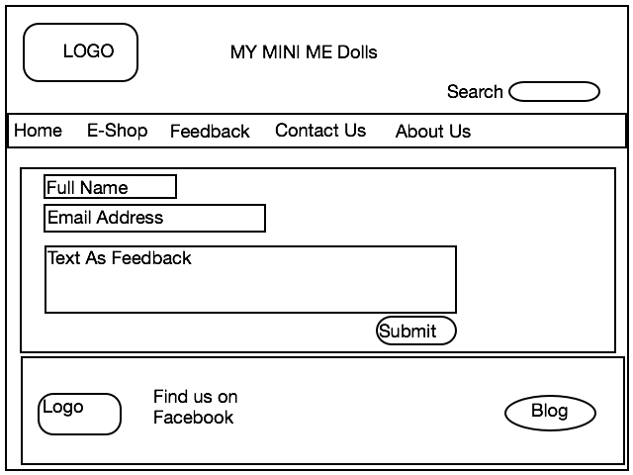

Contact Us:

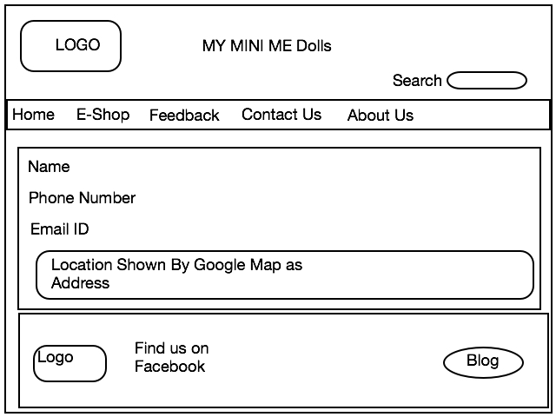

About Us:

